Java Arrays
Normally, an array is a collection of similar type of elements which has contiguous memory location.
Java array is an object which contains elements of a similar data type. Additionally, The elements of an array are stored in a contiguous memory location. It is a data structure where we store similar elements. We can store only a fixed set of elements in a Java array.
Array in Java is index-based, the first element of the array is stored at the 0th index, 2nd element is stored on 1st index and so on.
n Java, array is an object of a dynamically generated class. Java array inherits the Object class, and implements the Serializable as well as Cloneable interfaces. We can store primitive values or objects in an array in Java. Like C/C++, we can also create single dimensional or multidimensional arrays in Java.
Moreover, Java provides the feature of anonymous arrays which is not available in C/C++.
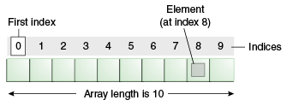

Advantages
- Code Optimization: It makes the code optimized, we can retrieve or sort the data efficiently.
- Random access: We can get any data located at an index position.

Disadvantages
- Size Limit: We can store only the fixed size of elements in the array. It doesn't grow its size at runtime. To solve this problem, collection framework is used in Java which grows automatically.

Types of Array in java
There are two types of array.
- Single Dimensional Array
- Multidimensional Array

Single Dimensional Array in Java
Syntax to Declare an Array in Java
- dataType[] arr; (or)
- dataType []arr; (or)
- dataType arr[];
Instantiation of an Array in Java
- arrayRefVar=new datatype[size];

Multidimensional Array in Java
In such case, data is stored in row and column-based index (also known as matrix form).
Syntax to Declare Multidimensional Array in Java
- dataType[][] arrayRefVar; (or)
- dataType [][]arrayRefVar; (or)
- dataType arrayRefVar[][]; (or)
- dataType []arrayRefVar[];
Example to instantiate Multidimensional Array in Java
- int[][] arr=new int[3][3];//3 row and 3 column
Example to initialize Multidimensional Array in Java
- arr[0][0]=1;
- arr[0][1]=2;
- arr[0][2]=3;
- arr[1][0]=4;
- arr[1][1]=5;
- arr[1][2]=6;
- arr[2][0]=7;
- arr[2][1]=8;
- arr[2][2]=9;

Multiplication of 2 Matrices in Java
In the case of matrix multiplication, a one-row element of the first matrix is multiplied by all the columns of the second matrix which can be understood by the image given below.
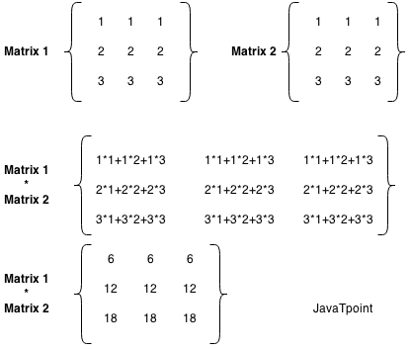
Let's see a simple example to multiply two matrices of 3 rows and 3 columns.
//Java Program to multiply two matrices
public class MatrixMultiplicationExample
{
public static void main(String args[])
{
//creating two matrices
int a[][]={{1,1,1},{2,2,2},{3,3,3}};
int b[][]={{1,1,1},{2,2,2},{3,3,3}};

//creating another matrix to store the multiplication of two matrices
int c[][]=new int[3][3]; //3 rows and 3 columns

//multiplying and printing multiplication of 2 matrices
for(int i=0;i<3;i++)
{
for(int j=0;j<3;j++)
{
c[i][j]=0;
for(int k=0;k<3;k++)
{
c[i][j]+=a[i][k]*b[k][j];
}//end of k loop
System.out.print(c[i][j]+" "); //printing matrix element
}//end of j loop
System.out.println();//new line
}
}
}

